PERSONAL INFORMATION | Muhammad Awais Qarni
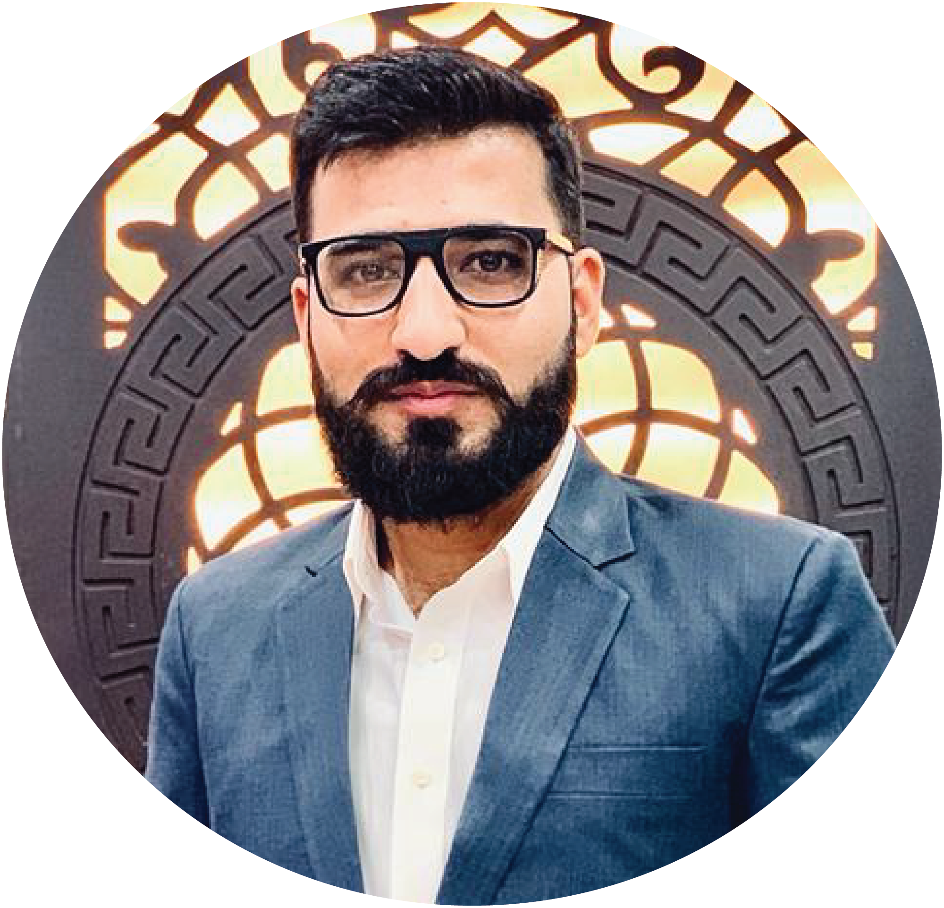 |   636, Street # 32 People Colony (Allama Iqbal Colony), Rawalpindi (46000) Punjab, Pakistan

(+92) 312-54 -96244  +92-312-5496244

official.qarni@gmail.com

https://m-awais-qarni-porfolio.vercel.app/
 |  https://www.linkedin.com/in/muhammad-awais-qarni-22ba25218/
 | Sex Male | Date of Birth 04/12/2000 | Nationality Pakistani

WORK EXPERIENCE

January 2023 - Present | IT Specialist (Full Stack Developer)
January 2023 - Present | Pakistan Air Force – Currently at 103-ALC, Nur Khan Base, Rawalpindi
January 2023 - Present | - Currently Working as a Full stack Developer with Angular Js as Front End, Dot Net Framework as backend, and MYSQL as Database. Working Tool Since Used is Visual Studio 2019.  - Designing and implementing a responsive Logistic Management System’s front-end using AngularJS, HTML, CSS, JavaScript, and jQuery.  - As a Dot NET developer, creating RESTful APIs to link front-end web applications to back-end services and data.  - Creating stored procedures and SQL queries to manage and manage data in relational databases.  - Collaborating with back-end developers, designers, and other stakeholders to produce high-quality online applications that satisfy corporate needs.  - Monitoring web applications' quality and functioning through unit and integration testing.  - Web application troubleshooting and debugging to fix problems and guarantee top performance.  - Creating technical specs, user guides, and manuals for online applications.  - Maintaining current with the newest market tendencies and recommended procedures for front-end web development, DOT NET, and SQL.  - Teaching and helping young and new developers with the best practices and methods for .NET, SQL, and front-end web development.
October 2022 – February 2023 | MERN Stack Training
October 2022 – February 2023 | Bitsol Technologies – 6th Road Rawalpindi (Office Address - Software Technology Park, 156 Service Rd N, I-9/3, Islamabad)
October 2022 – February 2023 | - Making use of the MERN stack (MongoDB,Express, React, and Node.js) to create full-stack web apps.  - Creating and managing databases using MongoDB and Mongoose.  - Designing and implementing RESTful APIs in Express.js to connect front-end web applications to back-end services and data.  - Developing responsive user interfaces using React.js, HTML, CSS, and JavaScript.  - Conduct unit testing and integration testing to ensure the quality and functionality of web applications.  - Troubleshooting and debugging web applications to resolve issues and ensure optimal performance.  - Reading and analyzing technical requirements, specifications, and user manuals for web applications.  - Staying up-to-date with the latest software industry trends and best practices in MERN stack development.  - Contributing to open-source MERN stack ideas, projects, and communities to enhance my skills, abilities, and knowledge.
January 2022 - Present | WordPress & Python Developer
January 2022 - Present | Freelancing – Fiver, Freelancer, Locally Task Manager, Assignment Worker
January 2022 - Present | - Designing and developing custom WordPress themes and plugins using PHP, HTML, CSS, and JavaScript.  - Configuring and customizing WordPress sites to meet client/user needs and specifications.  - Developing web applications using Python and related frameworks like Flask or Django.  - Collaborating with clients and stakeholders to gather requirements, develop technical specifications, and deliver high-quality web applications.  - Troubleshooting and debugging web applications to resolve issues and ensure optimal performance.  - Staying up-to-date in the field.  - Providing technical support and maintenance for WordPress and Python web applications.

EDUCATION AND TRAINING

September 2018 – August 2022 | Bachelor in Software Engineering
September 2018 – August 2022 | Apcoms Affiliated with the University of Engineering and Technology, Taxila  Address: H3H6, + MCQ, Khadim Hussain Rd, Lalazar, Rawalpindi (46000), Pakistan  Website: https://www.apcoms.edu.pk/  Filed(s) of Study: Software Engineering  Final Grade: 3.29 Max Grade: 4.00 Percentage: 82.25%  Final Year Project/Thesis: Facial Recognition-Based Intelligent Glasses for Amnesia  - A Semi-Hardware Software based device targeting people suffering from the disease of amnesia and can also be used by agencies. The system was developed using Python.
September 2018 – August 2022 | Major Subject(s) Taught/Self-Learned:  - Artificial Intelligence and Machine Learning  - Fundamental of Programming, Object Oriented Programming, and Data Structures and Algorithms  - Web Development (HTML, CSS, JavaScript)  - Computer Vision (Neural Networks)  - Embedded Systems (Final Year Project)

August 2016 – July 2018 | Intermediate
August 2016 – July 2018 | F.G Liaquat Ali Degree College, Peshawar Road, Rawalpindi (46000), Punjab, Pakistan  Address: J262+FMW, Bahadur Khan Rd, Peshawar Road, Rawalpindi (46000), Punjab, Pakistan  Filed(s) of Study: Pre-Engineering  Final Grade: 756 Max Grade: 1100 Percentage: 68.72%

April 2014 – July 2016 | Matriculation
April 2014 – July 2016 | F.G Boys High School R.A. Bazar, Rawalpindi (46000), Punjab, Pakistan  Address: H2QV+JJF, Rawalpindi (46000), Punjab, Pakistan  Filed(s) of Study: Sciences  Final Grade: 810 Max Grade: 1050 Percentage: 77.14%

PERSONAL SKILLS

Mother tongue(s) | - Urdu  - Punjabi
Other language(s) | UNDERSTANDING |  | SPEAKING |  | WRITING
Other language(s) | Listening | Reading | Spoken interaction | Spoken production
English | B1/2 | B1/2 | B1/2 | B1/2 | B1/2
Certificate: English Medium of Instruction (On the Basis of Bachelor Degree)

Levels: A1/2: Basic user - B1/2: Independent user - C1/2 Proficient user
Common European Framework of Reference for Languages

Communication skills | Good communication skills gained through experience  - In the dissemination of project results to diverse audiences (Software Engineers/Houses, policymakers, general public).  - Interaction with a broad spectrum of users.  - Of the Sea for Society project included organizing and facilitating software with citizens and stakeholders, thereby strengthening abilities to deal effectively with stakeholders at all levels.

Organizational/managerial skills | Good organizational skills enhanced through the work done in  - The Sea for Society project included the entire team of developers to deal with users and stakeholders.  - Similarly, the project (Currently Working on) helped to strengthen organizational skills through the various events organized for the project.  Can’t Enter the Name of the project due to the privacy policy of the organization
Job-related skills | - Proficiency in Angular Js.  - Familiarity with .NET Framework (ASP.NET MVC, Web API and C#).  - Knowledge of MYSQL (All CRUD Operation and Queries).  - Proficiency in HTML5, CSS3, JavaScript.  - Familiarities with Agile Methodologies like Scrum.  - Collaboratively in Team Environment.  - Knowledge of Version Control Systems like Git and GitLab.  - Have excellent attention to detail to write clean and optimized code.  - Continuous and quick Learning.

Computer skills | - Great typing Skills  - Programming/Coding Skills  - CMS systems for managing websites  - Software Problem Debugger and Solver  - Good command of Microsoft Office Tools (especially Word Excel and PowerPoint)

Other skills | - outdoor Sports Skills - Good in Basketball, Football (School-District Level Player) and Athlete(All Pakistan 800/1600 meters Race Participant – got 11th Position in All Pakistan 1600m Race in 2018)  - Indoor Sports Skills - Good in Chess and Swimming

ADDITIONAL INFORMATION

Personal Projects | 1. Constra-Construction Website (Web Development) (07/2020 - 02/2020)  - Developed a Demo website for a construction company using HTMl5, CSS3, JavaScript and  2. PHP. Medical Reception System (OOP) (03/2020 - 06/202)  - Developed a Reception System for Clinic/Hospital in C++ using Object Oriented Programming  3. Encryption Decryption using C++ (DSA) (09/2019 - 02/2020)  - Encrypting And Decrypting messages into Secret code that a normal human can't easily understand or decode.  4. E-commerce Website (MERN Stack)  - A E-commerce store is basically used as an online shopping store to purchase items like perfumes, and clothes (T-Shirts, Skirts, Shalwar-Kameez, Jeans, Pent -Shirts, Coats, etc) build in MERN stack Technologies.
Honors and Awards  Achievements | - Final Year Project (Facial Recognition-Based Intelligent Glasses for Amnesia) Nominated for PEC Expo 2023 By PEC held at Pakistan-China Friendship Centre, Garden Avenue, Shakarparian Rd, Islamabad  - Secure 1st Position for Final Year Project (Facial Recognition-Based Intelligent Glasses for Amnesia) in Open-house held at National University of Modern Languages Rawalpindi (46000)  - Best (FYP) Project of 2022 Open-House at NUML Rwp (46000)

